

**Object Oriented Programming**

**Project Idea Proposal**

On

**Bank Management System**

**Instructor: Dr Sher Muhammad Doudpota**

**Sana Fatima**

**By**

**(Group 12)**

**Nabeel Ahmed**

**Shivam Gehani**

Table of Contents

1. Introduction
2. Problem Statement
3. Project Goals and Objectives
4. Proposed Methodology
5. Major Outcomes
6. Project Timeline
7. Conclusion

**Introduction:**

As we all know that the **Banking System** is on peak to provide services from securing cash to withdrawing it anytime anywhere. These banking services are done through Programming Languages like C++, Java etc. In this regard, we have chosen a project namely, Bank Management System to show that how a Bank works which is nothing but a Desktop Application using Java. Our project will display the services like Account Creation, Transaction etc.

**Problem Statement:**

We all know that Technology has changed the paradigm of society. Previously the banks were having manual system of a user’s account which requires pages, pens and other things. Since account creation and transaction were done by human so there was a huge chance of errors. Additionally, the manual system required a lot of budget, time and management. There was not a backup system if data is destroyed. User has to wait in case of people in the queue inside the bank.

**Project Goals and Objectives:**

We should thank to technology for solving these issues. We will demonstrate in our project that how we overcome these problems using Java in which the user has not to worry about wasting his money as well as time. Our project goal is to provide user friendly interface to perform banking actions using Java Language. Since we had set some objectives to be implemented in our project. These objectives include

1. Admin Login
2. Create Account
3. Deposit Money
4. Withdraw Money
5. Check Balance
6. Backup Planning

**Proposed Methodology:**

Our methodology is same like an Ordinary Bank. We will be having login page for Administrator. Then the Administrator will provide service to the user like Account Creation, Balance Inquiry, Backup Planning, and Deposit/Withdraw Cash.

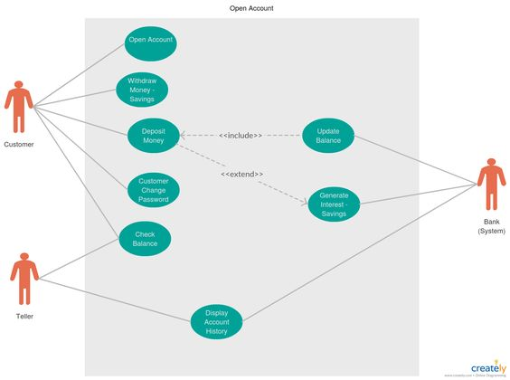To implement this methodology, we will be using Java’s

1. AWT (Abstract Window Toolkit) to decorate our project.
2. JDBC (Java Database Connectivity) to provide backup plan using MySQL or MS Access (depends on easiness)

The project is based on a Bank Management System in which we will be implementing our Java knowledge that can help the end user to run our project smoothly. We will be using internet and other resources to get help and learn new things to make it user friendly.

If we need some other things to learn like Exception Handling then it will be added in order to complete our project. Following is the UML prototype which will conclude our Proposed Methodology of Bank Management System.

**Major Outcomes:**

Bank Management System will help users to create account, check balance very easily. In addition, it keeps the transaction record and backup system. Lastly, it provides security and privacy to ensure the reliability of the user.

**Project Timeline:**

We will be arranging 5 meeting with below target to be accomplished every week.

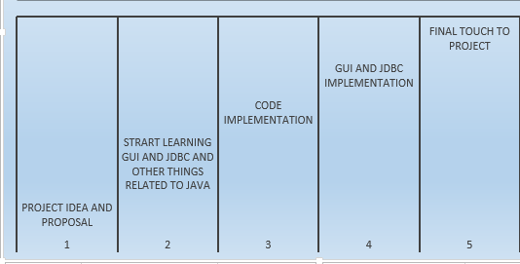

**Conclusion:**

We have created Banking Management System application for maintaining a person’s account in bank. This banking management system will help customers to perform basic financial transaction in banking platform. This application is created to facilitate the user to be on the track of online banking platform. We have created this bank management system with automated database functionality in order to maintain the records of customers which is very essential to manage the documents and personal information of customers. Furthermore, we will try our best to accomplish it as designed and implement additional features to make it more user friendly.

**Project Implementation:**

Whichever we said we have implemented that. Additionally, we have also added debit and credit. But we have missed to add transfer feature. Our project is implementing the basic concepts of java.

* Abstraction
* Polymorphism
* Encapsulation
* Packages
* GUI

here is our project

Discussion about project implementation:

***First page:***

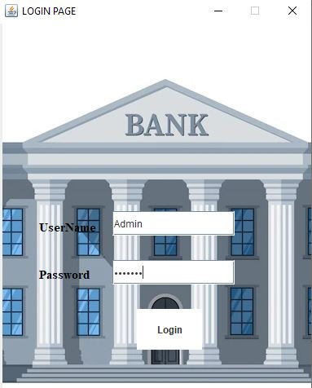

In this page we will input **Username** and **Password** in order to open Admin account. Otherwise, none has accessed for security reason.

***Second page:*** After login in the admin account, we will find this page which consist two options. Create Account and Other operations.

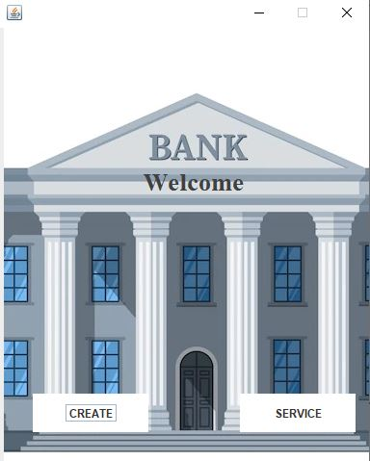

***Third page:***

**Page of Create Account:**

In this page we have added some text fields for customer information and check box for selecting **Gender,** In The text field of Account ID, Account number will be provided automatically. Then we click create button you will find a message “Account Created Successfully”. After the creation of account, the customer data will be saved in data base.

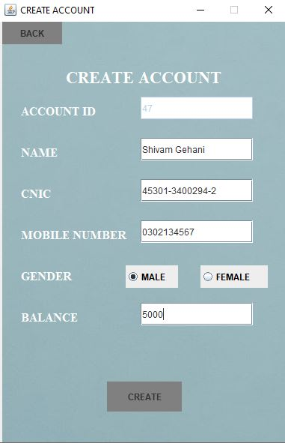

***Fourth page:***

**Page of other operations:**

In this page you will find multiple buttons for other banking tasks. Such as Deposit money, withdraw money, display info, other services, and delete account.

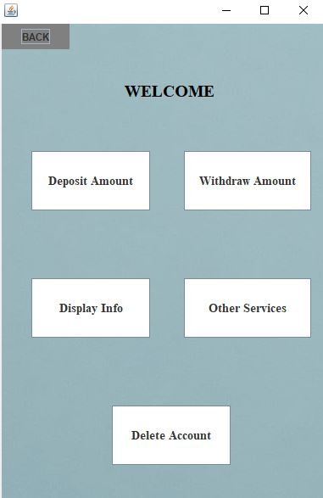

**Deposit Amount:**

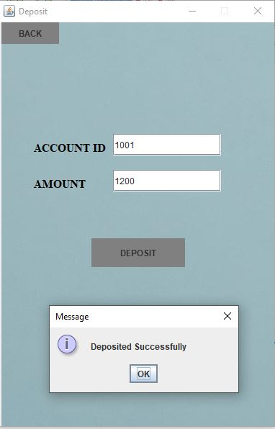

**Withdraw Amount:**

In these both section Account number will be input in order to Deposit or Withdraw Amount.

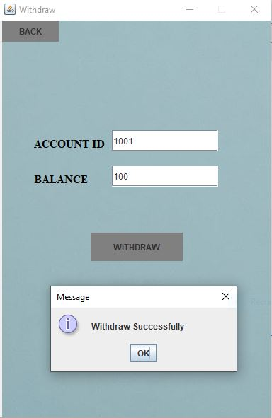

**Delete Account:**

Here customer info can be removed in delete account button. Through entering account number.

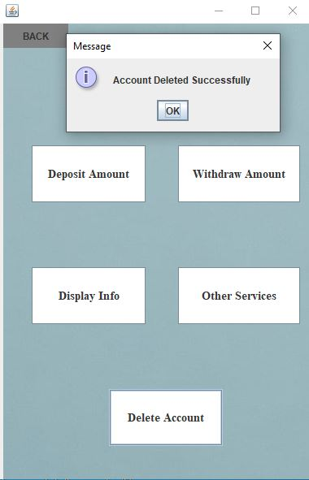

**Display information:**

In the customer information button, we will enter account number to display the customer information. And by clicking on the bank info button Admin can observe the bank information with total available balance in bank.

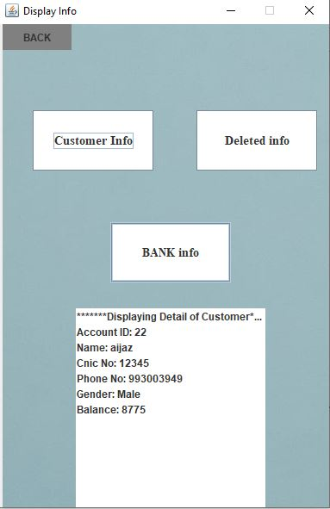

**Other Services:**

In other services customer will find credit card and debit card service.

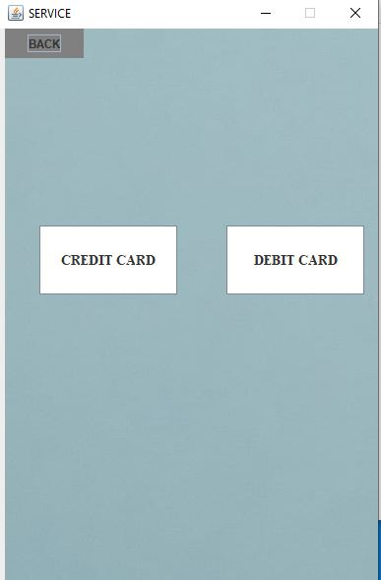

**Database**

The customer account information is stored in database.

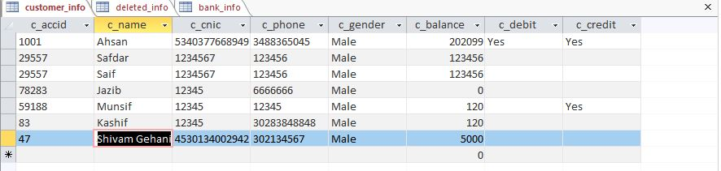

**Deleted Information of customer in Database:**

The deleted account of customer will also be stored in database. Which we can find through entering customer account number.